## MINI PROJECT – I

**(2020-21)**

# Meditation App

**SYNOPSIS**



**Submitted By: Submitted To:**

**Name: Dr. Manoj Varshney**

Uttam Singh (191500884) Technical Trainer

Prateek Rai (191500590) Department of Computer Engineering &

Umang Sharma (191500872) Applications

**Branch/Sec:**

Uttam Singh: CSE/O Prateek Rai: CSE/O Umang Sharma: CSE/O

**INTRODUCTION**

In this fast-growing world, everyone is busy in the race of coming first. No one has time to do any other stuff. This Busyness increases stress level in human and make human irritable. In this growing world with lots of technologies we make our life very easy by using lots of technical tools but slowly we lost our patience too. In this race of coming first we have no time to do proper exercise, yoga and meditation. So, to resolve this problem I made a Meditation Web Application where user can set timer and meditate for a time set on the timer.

In growing world of technologies, we need some time for ourselves to make us more productive. To increase productivity we need proper functioning of brain. For brain we need piece.

The main objective to made this web application is to provide a break to all users so that they can meditate and increase their productivity.

# EXISTING SYSTEM

This project is about meditation , there are many meditation app available on app store and web browser but we found few problems in that like a person can’t set the timer by themselves and he/she also can’t modify background as per their choice and we have put some changes in this meditation app which we will see in the feasibility of project given below. There are some application that are available are listed below.

1. **Best Overall:** [Calm](https://www.calm.com/)
2. **Best Budget:** [Insight Timer](https://insighttimer.com/)
3. **Best for Sleep:** [Headspace: Meditation & Sleep](https://headspace.pxf.io/c/2104074/1125973/13686?subid1=4767322&subid2=na0d5e0f75547418f8f6785fae10cfdaa10)
4. **Best for Beginners:** [Ten Percent Happier Meditation](https://www.tenpercent.com/)
5. **Best Guided:** [Buddhify](https://buddhify.com/)
6. **Best For Focus:** [Unplug](https://www.unplug.com/)
7. **Best Selection:** [Simple Habit](https://www.simplehabit.com/)

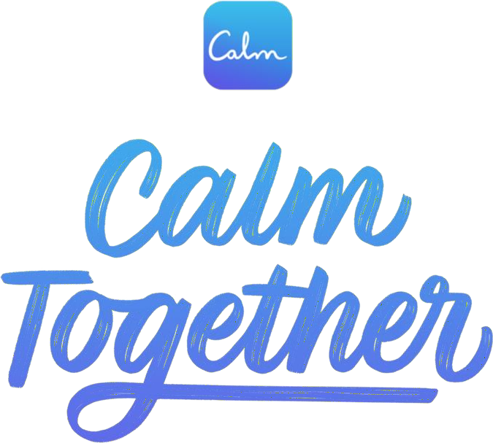

Figure - 1 Calm app poster

## USE OF THE PROJECT

Meditation APP will help us in various ways as defined:

1. **CONCENTRATION**

Meditation is NOT concentration. [Concentration](https://www.stylecraze.com/articles/simple-concentration-exercises/) is when you put your undivided focus on an object and stay that way for quite some time. The methods and techniques, which are often used in visualization, are the other different kinds of concentration.

1. **EXERCISE**

Meditation has nothing to do with working out. It doesn’t consist of postures and breathing techniques as such. Neither does it consist of rigorous movement or profuse sweating. Meditation is all about finding your inner soul and making peace with it.

1. **REDUCES STRESS:**

One benefit of listening to music while meditating is a reduction in the levels of stress and anxiety. Stress is one of the most common issues in today’s world. If your workload is very demanding, it is very natural for you to feel stressed-out often. When you listen tpleasant and soft music during meditation, you will feel calmer and eliminate stress from your life.

## FUNCTIONAL SPECIFICATION

In this web application named as meditation app we have made few changes unlike of others meditation apps we have modified this app as we implemented music setup, background motion pictures and we also set the timer in the music player where user can easily set the timer of music by their own (for example – 2, 4 or 5min as per their need).

# Software Specification:

* Language Used : Python
* Database : CSS, HTML
* User Interface Design : Virtual studio code, Sublime Text Editor
* Web Browser : Google Chrome

## Hardware Requirements:

* Processor : 64-bit, four-core, 2.5 GHz minimum per core
* Operating System : Windows 10,
* RAM : 8GB
* Hard disk : 1024 GB
* Display : 1280 x 768 screen resolution

**FUTURE SCOPE**

This project has a very vast scope in future and can be easily implemented under various situations. Project can be updated in near future as and when requirement for the same arises, as it is very flexible in terms of expansion. We can add new features as and when we require.

The following are the future scope for the project.

* 1. Receiving student complaints and provides them their complaint status.
  2. Higher speed of receiving complaints.
  3. Distribution of related complaints among different departments, etc.